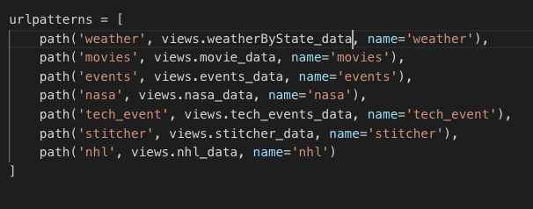

We used Django for this project.

This is simply where I added my app to the list of URL patterns.

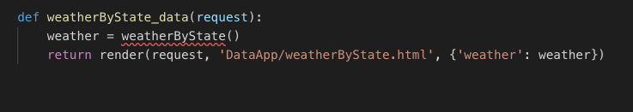

This is a javascript function that calls the code in the previous image when loading the webpage.

'onload' can be added to call this function after the rest of the site is loaded.

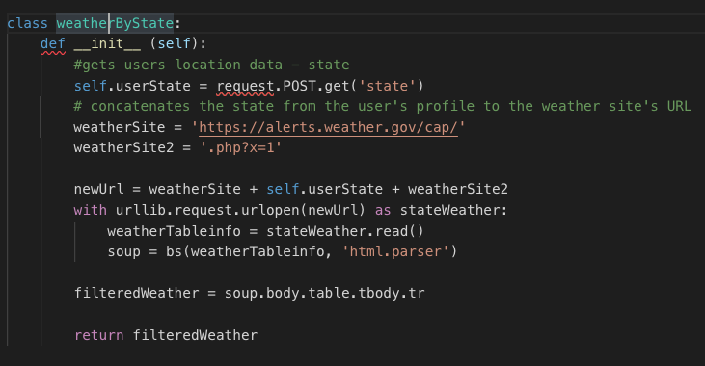

This is the functional code for the application itself.

Using request module, it gathers the users location data. Then plugs the users data into the url for the weather.gov website so that a webpage with their local weather info comes up. Then uses beautifulsoup to parse the web page's html for the relevant info I would like displayed.

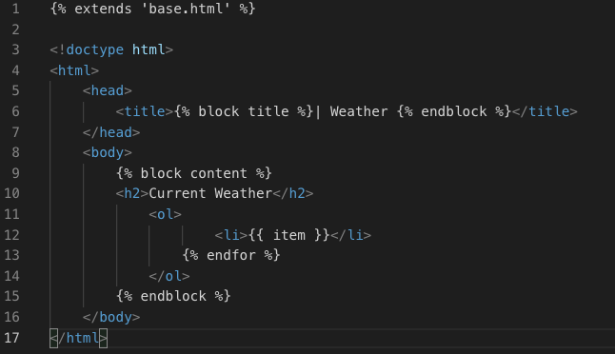

This is the front end display of the widget.

'{% block title %}' uses the blocks of html written for the entire site so that the style remains consistent.

'{{ item }}' is where I placed the code that pulls data from the API, etc.